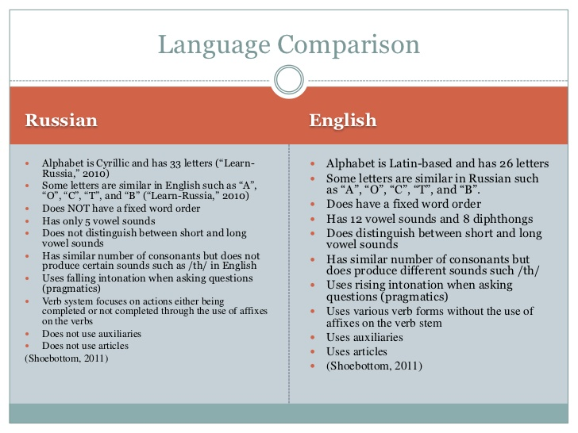
Retrieved from: https://www.slideshare.net/naa134/language-comparison-10357380

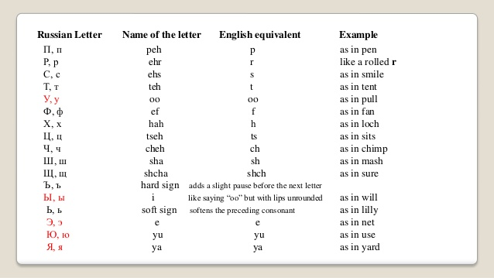

Retrieved from: https://image.slidesharecdn.com/lecture1pdffile-140410113405-phpapp01/95/russian-alphabet-8-638.jpg?cb=1397129718

Resource to learn more about Russian/Russian Articulation Screener:
https://www.smartspeechtherapy.com/shop/russian-articulation-screener/

Guide to Helping Children Produce a Sound

Introduction: Producing sounds takes lots of practice. It is best to first start out by figuring out which sound a child has difficulty with, and how they might produce that sound when the sound is at the beginning, middle, or end of the word. Then, it is important to try making the sound all by itself. This step might take some time. After that, children can work on making the sounds in syllables, words, sentences, and finally in conversation. Below is a step-by-step guide to help caregivers and therapists work together to help the child make new sounds.

Target Sound(s): ________________

English |  |  | Russian (Translate from English section)
Step | Task | How to do the Task
1 | Assess how the child can say a sound when the sound is the beginning, middle, and end of the word. That way, we can identify which words we can start off with first. | Create a list of words with the target sound in the beginning, middle, and end positions. If possible, also create a list of words when the sound is within a consonant cluster (like in the word black).
2 | Have child practice making the sound in isolation. This will involve working on the small parts that make us produce the sound. | Think about the steps needed to create the sound. How does it feel in your mouth? Where is your tongue? Are your lips rounded or in a smile?  For example, for the trilled r (p) in Russian, we first need to work on how to blow air, where to place our tongue, and how to move our tongue quickly from front to back. Example: https://youtu.be/0J_Qg1AzTX8  Each time the child attempts to make one part of the sound, we give them feedback to help them get the sounds correctly. For example, we can say something like, “Good try! I like that you blow air. Next time, put your tongue behind your teeth.”
3 | Have child produce the target sound in small parts, also known as syllables. | Create list of syllables that combine the target sound with different vowels (example: ba, bo, bee). Provide child with feedback every time they produce the syllable. Be specific with feedback. When correct, say something like, “Yes! I like how you put your tongue behind your teeth!” If incorrect, say something like, “Great try! Next time, place your tongue behind your teeth.”
English |  |  | Russian (Translate from English)
Step | Task | How to do Task
4 | Have child produce the target sound in words. Start out with words that will make it easier to make the target sound. For example, if the target sound is trilled r, avoid consonants that are rounded vowels. | Create list of at least 10 words with the target sound (example: baby, bottle). Find pictures that go with the words. Provide child with feedback every time they produce the word. Be specific with feedback. When correct, say something like, “Yes! I like how you put your tongue behind your teeth!” If incorrect, say something like, “Great try! Next time, place your tongue behind your teeth.”
5 | Have child practice saying sentences that have words that start out with the target sound. | Show the child a picture of a word that has the target sound. Show the child the picture, and have them say a sentence using the word depicted in the picture. Provide child with feedback every time they produce the word. Be specific with feedback. When correct, say something like, “Yes! I like how you put your tongue behind your teeth!” If incorrect, say something like, “Great try! Next time, place your tongue behind your teeth.” At this stage, you can also ask the child to tell you how they think they did. You can say, “How did that sound to you?”
6 | Have child practice the target sound in conversation. | Show the child a picture of a word that has the target sound. Show the child the picture, and have them say a sentence using the word depicted in the picture. Provide child with feedback every time they produce the word. Be specific with feedback. When correct, say something like, “Yes! I like how you put your tongue behind your teeth!” If incorrect, say something like, “Great try! Next time, place your tongue behind your teeth.” At this stage, you can also ask the child to tell you how they think they did. You can say, “How did that sound to you?”

General Recommendations to Working with Interpreters

  - Break down what you want to do in therapy into smaller steps. Write down the steps to help guide your interpreter.

  - Work with the interpreter ahead of time to help identify appropriate stimuli in the language you do not speak fluently. (See action items the interpreter can do above in blue text).

  - Each time you are working on a new task in therapy, explain to the interpreter why you are doing it, and why asking questions and providing specific feedback in the way you are showing is important for learning.

